Leçon de musique pour les 2e année

This week, we will review the rhythm with a game you can play with your family: The Can Can song play-along.

- Clap your hands instead of using instruments.
- Explore the sounds in your home and find toys or objects you can use instead of instruments.
- If you do have instruments, play with them!

I miss you! Please write me an e-mail (marie-maude.allard@yesnet.yk.ca) about the fun you had playing the Can Can game. Can you draw the rhythmic symbols found in the game and send a picture of your drawing?

Explore my website. Did you find the FREEZEDANCE game?
What is your favorite video and song in the website?

P.S. You don’t have to do the activities presented in the video about wind instruments.

Here’s the link to the website:
https://marie-maudeallard.wixsite.com/musique/2e-3e-annee

Leçon de musique pour les 3e année

This week, we will review the rhythm and the beat with a game you can play with your family: The Can Can song play-along.

- Clap your hands instead of using instruments.
- Explore the sounds in your home and find toys or objects you can use instead of instruments.
- If you do have instruments, play with them!
- Play again, but this time, keep the beat (pulsation)

I miss you! Please write me an e-mail (marie-maude.allard@yesnet.yk.ca) about the fun you had playing the Can Can game. Can you draw the rhythmic symbols found in the game and send a picture of your drawing? Can you tell be the difference between the rhythm and the beat in a text or an audio recording?

Explore my website. Did you find the FREEZEDANCE game?
What is your favorite video and song in the website?

P.S. You don’t have to do the activities presented in the video about wind instruments.

Here’s the link to the website:
https://marie-maudeallard.wixsite.com/musique/2e-3e-annee
Music lesson without screen
Create a board game!

- Print or draw a grid like this one

- Put one rhythmic symbol in each square. You can print the rhythmic symbols below or draw the symbols yourself.

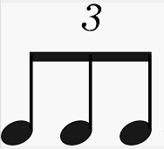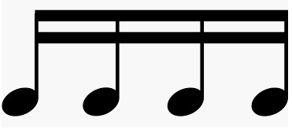
Tah Take Takité Takatimi

- Cut 10 blanc cards and write one special feature on each of them.

Move fast (presto tempo)
Move slow (adagio tempo)
Say the Konnakol words as you move
Double your turn
Pass your turn

- Decide where to start and where to finish.
- Take tokens from another game or make as many as you need.
- You will need a dice.
- The game : roll the dice and move accordingnly to the number, but play the rhythm writen the board as you move along. You want to make it harder? Pick a card and play as it asks.

I miss you! Send a picture of your game (marie-maude.allard@yesnet.yk.ca)! Hope you have tons of fun with your family.

Mme Marie-Maude

