May 25, 2020

Dear EWES families,

My name is Madame Kim Arkesteyn-Vogler and I am the Teacher-Librarian at EWES. I have had the pleasure of meeting all your children and helping them find the perfect books during their weekly library periods.

As we move through these extraordinary times, I will be providing periodic art activities to do at home between now and June 12th. These will come to you through your child’s teacher, either in an email or posted on their website, and are meant to supplement what the classroom teachers are providing as curriculum. These are fun, grade-appropriate art projects that you can do as a family and are in no way mandatory. If you have any questions or need support, please don’t hesitate to contact me. I will be answering emails between 10am and noon, Monday to Friday. I hope you enjoy the activities I have planned!

Sincerely,

Madame Kim Arkesteyn-Vogler
Teacher-Librarian
Ecole Whitehorse Elementary
Kim.arkesteyn@yesnet.yk.ca

NATURE PHOTO FRAMES

Who doesn’t love nature treasures? If you guys are like my two kids, you probably come back from a forest walk with pockets full of rocks, pinecones, needles, sticks, fur, bark, leaves… At our house, these just pile up on our front porch and never amount to anything. This is your chance to turn your nature treasures into a beautiful photo frame.

What you will need:
- Scissors
- Cardboard or plastic (cereal boxes or 4L milk jugs work great)
- Nature treasures (small rocks, needles/leaves, moss, twigs, cones, bark)
- Craft supplies (paper, cardboard, felt, string, twine, stickers, foam)
- Glue (hot glue works best, white school glue and glue sticks work well too)
- Markers/pencils/pencil crayons/crayons

Instructions:
- Go outside and collect items from nature. Please ONLY collect items that have fallen on the ground. We don’t want to hurt the plants!

- At home, cut a frame out of cardboard or a plastic jug. Before you cut, decide on the size of picture you want to put in the frame. A regular photo is 4’ by 6’ and a sheet of paper is 8.5’ by 11’. Draw your 4 by 6 (or 8.5 by 11) rectangle on the cardboard/plastic. Measure a 2’ all the way around your first rectangle. This will create a second, larger rectangle. Cut out both rectangles. (see pictures below)
8.5’ by 11’ rectangle. Cut this out to create a space for your picture
2’ rectangle around first rectangle. This is your frame.

**Please ask an adult for help if you are cutting a milk jug or other hard plastic**

- Paint or colour or glue colourful paper to the frame to make it your favourite colour

- Glue your nature items and craft supplies onto your picture frame to create a beautiful work of art to showcase your picture or drawing.
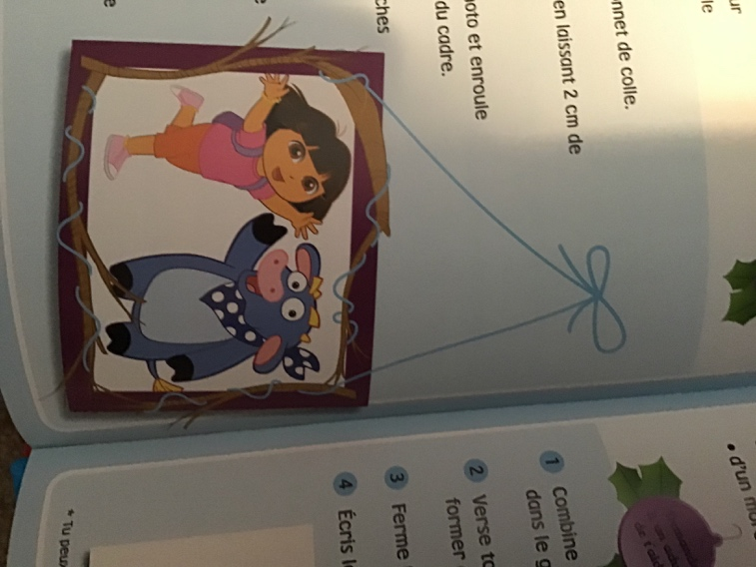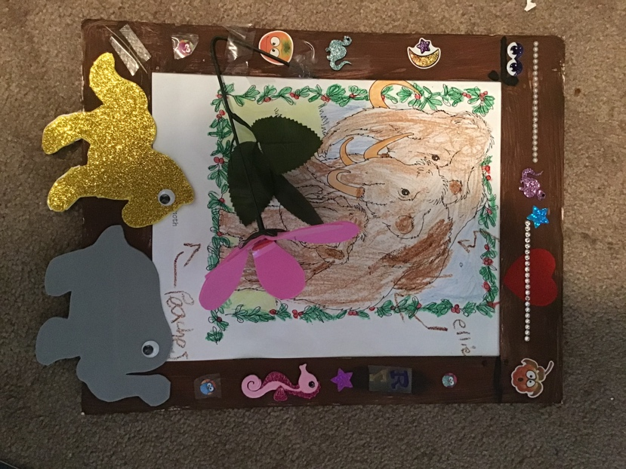
Photo frame decorated with stickers
Photo frame decorated with twigs and string

If you would like to share your creation with your teacher and the EWES school community, please email a picture to: kim.arkesteyn@yesnet.yk.ca and it will be posted to the school Facebook page and/or your teacher’s website. (Please note that by sending us a picture, you consent to having it posted to the Facebook page and teacher website. Thank you.)

Kind Regards,

Madame Kim Arkesteyn-Vogler
Teacher-Librarian
Ecole Whitehorse Elementary

